Q1

Using OOP principles, describe the process of creating a system with a well-labeled diagram.

Start by identifying the main objects in the system, which represent entities in the problem domain.

Create a corresponding class for each identified object, as a blueprint or template that defines the properties and behaviors of objects.

Determine the attributes of each class, which define the state of the objects.

Identify the methods that operate on the data and behaviors of each class, defining the actions or operations that can be performed on objects of a class.

Encapsulate the attributes and methods within the classes, restricting access to certain components of an object and protecting the integrity of the object's state.

Identify relationships between classes, including associations, inheritance, and composition.

Instantiate objects from the defined classes, representing specific entities in the system.

Apply inheritance where appropriate, allowing a class to inherit properties and behaviors from another class, promoting code reuse and establishing an "is-a" relationship.

Implement polymorphism, enabling flexibility and extensibility in the system, allowing objects of different classes to be treated as objects of a common superclass.

Use abstraction to hide unnecessary details and focus on essential features, employing abstract classes and interfaces to define a common set of methods that subclasses must implement.

Test the system through unit testing, integration testing, and system testing to ensure that it behaves as expected, verifying the correctness and reliability of the implemented system.  
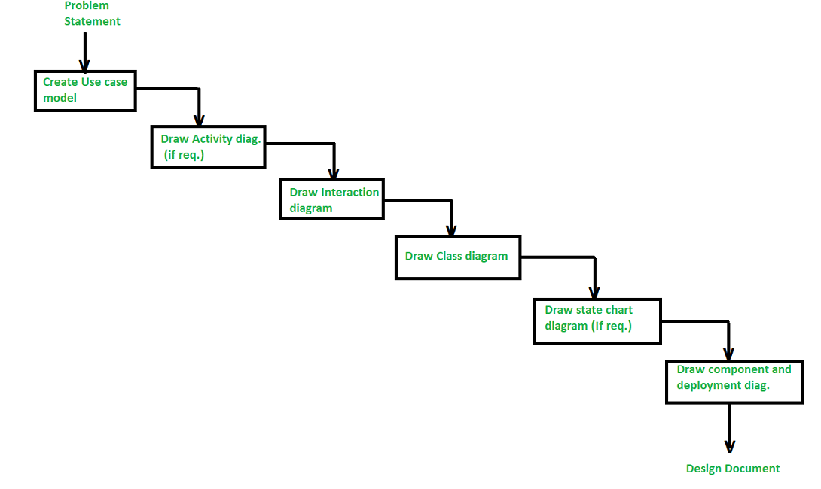

Q2

What is the Object Modeling Techniques (OMT).

is a real-world-based modeling approach used for software modeling and designing.

Q3

Object-oriented analysis and design (OOAD) and object analysis and design (OOP) can be compared as follows:

1) Object-Oriented Analysis and Design (OOAD):

a. The process of analysis involves a thorough study of a system to identify its objects, their relationships, and their characteristics. The focus is on comprehending the problem domain and determining what needs to be done.

b. During design, the identified objects are defined in terms of how they will interact to fulfill the system's requirements. This includes designing classes, relationships, and methods to implement the system.

2) Object-Oriented Programming (OOP):

a. Programming refers to the actual implementation of the system using an object-oriented language such as Java, Python, or C++. In OOP, you write code using classes and objects, encapsulation, inheritance, and polymorphism, applying the principles identified during analysis and design.

Q4

Please find below the reworded version of the given text as per your request:

Discuss the main objectives of UML.

1) Standardization:

UML aims to establish a consistent modeling language that enables practitioners, analysts, designers, developers, and other stakeholders to effortlessly communicate and share information. The standardization of UML ensures uniformity and interoperability across different software development projects.

2) Visual Representation:

UML provides a graphical notation that allows developers to visually represent various aspects of a software system. This graphical representation helps in comprehending complex systems more easily than textual descriptions, making it a powerful tool for communication among team members and stakeholders.

3) Modeling Abstraction:

UML supports different levels of abstraction, enabling modelers to represent a system from various perspectives. This includes high-level conceptual models, detailed design models, and even models representing the implementation. The ability to model at different levels of abstraction contributes to better communication and understanding of complex systems.

4) Communication and Collaboration:

UML facilitates communication among stakeholders by providing a common language that is not overly technical or tied to a specific programming language. This enables developers, architects, business analysts, and other stakeholders to collaborate effectively, ensuring that everyone involved in the project has a shared understanding of the system.

5) Documentation:

UML serves as a powerful documentation tool for software systems. It allows developers to document the architecture, design, and implementation details of a system in a visual and standardized way. This documentation is valuable for maintaining, evolving, and transferring knowledge about the system over time.

6) Flexibility and Extensibility:

UML is designed to be flexible and extensible, allowing practitioners to adapt it to their specific needs. It provides a set of core diagrams (e.g., class diagrams, sequence diagrams) but also allows for the creation of custom diagrams and extensions, making it versatile for different types of systems and domains.

7) Analysis and Design Support:

UML supports both analysis and design activities in software development. It allows modelers to represent requirements, use cases, classes, relationships, and various other aspects of a system. This makes it a comprehensive tool for capturing and visualizing the entire software development process.

Q5

1. When developing an information system using object-oriented programming, creating classes that encapsulate both data and functions allows for modularity, simplifying troubleshooting by isolating problem areas more efficiently. This also enables multiple team members to work simultaneously without duplicating functionality, as each object operates independently.

2. Object-oriented programming allows for the reuse of code through inheritance. Instead of building new objects from scratch, a generic class can be defined and subclasses can be created to inherit the traits of the generic class while maintaining their unique attributes and functions. This technique saves time and promotes code reuse.

3. Object-oriented programming emphasizes reusability by allowing the reuse of existing facilities (classes) rather than the creation of new ones. By creating modular, self-contained objects, they can be easily integrated into larger systems. Additionally, object-oriented programming systems can scale seamlessly from small to large projects, making maintenance more manageable..

Q6

Briefly explain the following terms as used in object-oriented programming. Write a sample java code to illustrate the implementation of each concept. [12 Marks]

* 1. Constructor
  2. object
  3. Destructor
  4. polymorphism
  5. class
  6. Inheritance

1. Constructor:
   1. A constructor is a special method within a class that gets called when an object of that class is created. It initializes the object’s state (i.e., sets initial values for its attributes). Constructors have the same name as the class and do not have a return type.

Example Java code with a constructor:

class Car {

private String make;

private String model;

// Constructor

public Car(String make, String model) {

this.make = make;

this.model = model;

}

public void displayInfo() {

System.out.println("Make: " + make + ", Model: " + model);

}

}

public class CarDemo {

public static void main(String[] args) {

Car myCar = new Car("Toyota", "Camry");

myCar.displayInfo();

}

}

1. Object:
   1. An object is an instance of a class. It represents a real-world entity or concept. Objects have attributes (data) and methods (functions) associated with them.
   * Example Java code creating an object:

public class ObjectExample {

public static void main(String[] args) {

Car myCar = new Car("Honda", "Civic");

myCar.displayInfo();

}

}

1. Destructor (Note: Java does not have explicit destructors):
   1. A destructor is a method that gets called when an object is destroyed or goes out of scope. In Java, the garbage collector automatically handles memory deallocation, so explicit destructors are not needed.
2. Polymorphism:
   1. Polymorphism allows objects of different classes to be treated as objects of a common superclass. It enables method overriding and dynamic method dispatch.

Example Java code demonstrating polymorphism:

class Animal {

public void makeSound() {

System.out.println("Animal makes a sound");

}

}

class Dog extends Animal {

@Override

public void makeSound() {

System.out.println("Dog barks");

}

}

public class PolymorphismExample {

public static void main(String[] args) {

Animal myAnimal = new Dog(); // Polymorphism

myAnimal.makeSound(); // Calls Dog's overridden method

}

}

1. Class:
   1. A class is a blueprint or template for creating objects. It defines attributes (fields) and methods that the objects of that class will have.
   * Example Java code defining a class:

class Student {

private String name;

private int age;

public Student(String name, int age) {

this.name = name;

this.age = age;

}

public void displayInfo() {

System.out.println("Name: " + name + ", Age: " + age);

}

}

1. Inheritance:
   1. Inheritance allows a new class (subclass or derived class) to inherit properties and behaviors from an existing class (superclass or base class). It promotes code reuse.
   * Example Java code demonstrating inheritance:

class Employee {

protected String empId;

public Employee(String empId) {

this.empId = empId;

}

public void displayEmpInfo() {

System.out.println("Employee ID: " + empId);

}

}

class Manager extends Employee {

private String department;

public Manager(String empId, String department) {

super(empId); // Call superclass constructor

this.department = department;

}

public void displayManagerInfo() {

System.out.println("Department: " + department);

}

}

Q7: *EXPLAIN* the three types of associations (relationships) between objects in object oriented.

Certainly! In object-oriented programming (OOP), there are three fundamental types of associations or relationships between objects. Let’s explore each of them:

* Association:

Association represents a semantically weak relationship between otherwise unrelated objects. It is a “using” relationship where two or more objects interact without any ownership or parent-child connection.

Example: Consider the relationship between a doctor and a patient. A doctor can be associated with multiple patients, and conversely, a patient can visit multiple doctors. Each object (doctor or patient) has its own lifecycle, and there is no ownership.

Code Example:

public class IDGBlogAccount

{

private IDGBlogEntry[] blogEntries; // Other members of the IDGBlogAccount class

}

public class IDGBlogEntry

{

Int32 blogId;

string caption;

string text;

// Other members of the IDGBlogEntry class

}

* Aggregation:

Aggregation is a specialized form of association where each object has its own lifecycle, but there exists an ownership relationship. It represents a whole/part or parent/child relationship.

Example: An employee may belong to one or more departments in an organization. If a department is deleted, the employee object continues to exist independently.

Key Property: The whole (parent) can exist without the part (child), and vice versa. The relationships are not reciprocal.

Code Example:

public class IDGBlogAuthor

{

// Other members of the IDGBlogAuthor class

}

public class IDGBlogAccount

{

// Other members of the IDGBlogAccount class

private IDGBlogAuthor[] authors; // Aggregation relationship

}

* Composition:

Composition is a stronger form of aggregation. It denotes a strict ownership relationship where the whole (parent) manages the lifecycle of its parts (children).

Example: A car consists of engine, wheels, and other components. If the car is destroyed, its parts are also destroyed.

Key Property: The whole (parent) and its parts (children) have a lifecycle dependency.

Code Example:

public class Car

{

private Engine engine; // Composition relationship

private Wheel[] wheels; // Composition relationship

// Other members of the Car class

}

qWhat do you mean by class diagram? Where it is used and also discuss the steps to draw the class diagram with any one example.

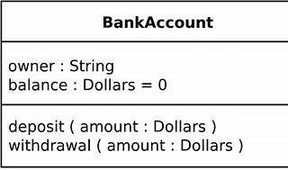

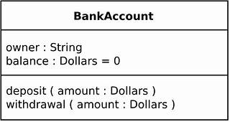

1. A Class Diagram is a static structure diagram in UML that illustrates the system's structure by displaying:

• Classes: Representing the fundamental components of the system.

• Attributes: Characteristics or data linked with each class.

• Operations (Methods): Functions or actions that classes can execute.

• Relationships: Indicating how classes interact with one another.

2. Purpose and Usage:

• Visualizing Structure: Class diagrams provide a visual depiction of the system's static structure. They help developers understand the relationships and dependencies among classes.

• Notation Foundation: Class diagrams serve as the foundation for other UML structure diagrams (like component and deployment diagrams).

• Code Generation: They can be used to construct executable code during forward and reverse engineering of a system.

3. The Steps to Draw a Class Diagram:

• Identify Classes:

Start by identifying the key classes in your system. These represent the major components or entities.

• Add Attributes and Methods:

For each class, list its attributes (data members) and methods (functions).

• Define Relationships:

Determine the relationships between classes:

• Association: Represents a weak relationship between unrelated objects.

• Aggregation: Depicts a whole/part relationship with ownership.

• Composition: A stronger form of aggregation with strict ownership.

• Draw the Diagram:

Use UML notation to create the class diagram:

• The class name in the first partition.

• Attributes in the second partition (with types).

• Methods in the third partition (with return types).

• Connect classes using lines to represent relationships (inheritance, association, etc.).

4. Example: Let's consider a simple library management system:

• Classes:

Book: Represents a book with attributes like title, author, and ISBN.

Library: Represents a library with attributes like name and location.

• Relationships:

Library has an aggregation relationship with Book (a library contains multiple books).

Book has an association relationship with Library (books are associated with a library).Here’s a simplified class diagram for our example:

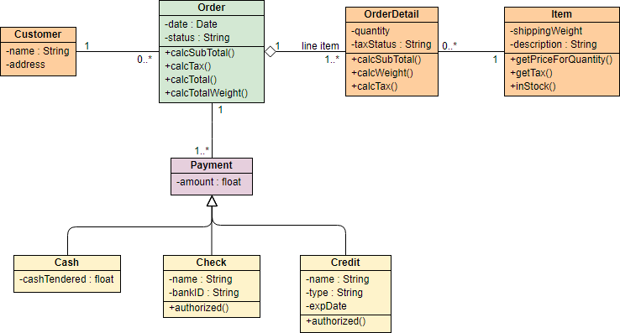

Q10: Given that you are creating area and perimeter calculator using C++, to computer area and perimeter of various shaped like Circles, Rectangle, Triangle and Square, use well written code to explain and implement the calculator using the following OOP concepts. a. Inheritance (Single inheritance, Multiple inheritance and Hierarchical inheritance) [10 Marks] b. Friend functions [5 Marks] c. Method overloading and method overriding [10 Marks] d. Late binding and early binding [8 Marks] e. Abstract class and pure functions

#include <iostream>

#include <cmath>

#ifndef SHAPE_H

#define SHAPE_H

#define PI 3.14159265358979323846

class Shape {

public:

virtual double getArea() const = 0;

virtual double getPerimeter() const = 0;

};

class Circle : public Shape {

private:

double radius;

public:

explicit Circle(double r) : radius(r) {}

double getArea() const override {

return PI * std::pow(radius, 2);

}

double getPerimeter() const override {

return 2 * PI * radius;

}

};

class Rectangle : public Shape {

private:

double length;

double width;

public:

Rectangle(double l, double w) : length(l), width(w) {}

double getArea() const override {

return length * width;

}

double getPerimeter() const override {

return 2 * (length + width);

}

};

class Triangle : public Shape {

private:

double base;

double height;

public:

Triangle(double b, double h) : base(b), height(h) {}

double getArea() const override {

return 0.5 * base * height;

}

double getPerimeter() const override {

return 3 * base;

}

};

class Square : public Rectangle {

public:

explicit Square(double side) : Rectangle(side, side) {}

};

#endif

int main() {

double radius, length, width, base, height;

std::cout << "Enter the radius of the circle: ";

std::cin >> radius;

Circle circle(radius);

std::cout << "Enter the length and width of the rectangle: ";

std::cin >> length >> width;

Rectangle rectangle(length, width);

std::cout << "Enter the base and height of the triangle: ";

std::cin >> base >> height;

Triangle triangle(base, height);

std::cout << "Enter the side length of the square: ";

std::cin >> length;

Square square(length);

std::cout << "\nCircle: Area = " << circle.getArea() << ", Perimeter = " << circle.getPerimeter() << std::endl;

std::cout << "Rectangle: Area = " << rectangle.getArea() << ", Perimeter = " << rectangle.getPerimeter() << std::endl;

std::cout << "Triangle: Area = " << triangle.getArea() << ", Perimeter = " << triangle.getPerimeter() << std::endl;

std::cout << "Square: Area = " << square.getArea() << ", Perimeter = " << square.getPerimeter() << std::endl;

return 0;

}

6

Q11: public class CalculateG {

// Method for multiplication

public double multi(double a, double b) {

return a * b;

}

// Method for powering to square

public double square(double x) {

return x * x;

}

// Method for summation

public double sum(double x, double y) {

return x + y;

}

// Method for printing out a result

public void outline(String message, double value) {

System.out.println(message + value);

}

public static void main(String[] args) {

CalculateG calculator = new CalculateG();

double gravity = -9.81; // Earth's gravity in m/s²

double fallingTime = 30.0; // Time in seconds

double initialVelocity = 0.0; // Initial velocity in m/s

double initialPosition = 0.0; // Initial position in meters

// Compute final position

double finalPosition = 0.5 * calculator.multi(gravity, calculator.square(fallingTime))

+ calculator.multi(initialVelocity, fallingTime) + initialPosition;

// Compute final velocity

double finalVelocity = calculator.sum(calculator.multi(gravity, fallingTime), initialVelocity);

// Output results

calculator.outline("The object's position after " + fallingTime + " seconds is ", finalPosition);

calculator.outline("The object's velocity after " + fallingTime + " seconds is ", finalVelocity);

}

}

Create methods for multiplication, powering to square, summation and printing out a result in CalculateG class

public class CalculateG {

// Method for multiplication

public double multi(double a, double b) {

return a * b;

}

// Method for powering to square

public double square(double x) {

return x * x;

}

// Method for summation

public double sum(double x, double y) {

return x + y;

}

// Method for printing out a result

public void outline(String message, double value) {

System.out.println(message + value);

}

public static void main(String[] args) {

CalculateG calculator = new CalculateG();

double gravity = -9.81; // Earth's gravity in m/s²

double fallingTime = 30.0; // Time in seconds

double initialVelocity = 0.0; // Initial velocity in m/s

double initialPosition = 0.0; // Initial position in meters

// Compute final position

double finalPosition = 0.5 * calculator.multi(gravity, calculator.square(fallingTime))

+ calculator.multi(initialVelocity, fallingTime) + initialPosition;

// Compute final velocity

double finalVelocity = calculator.sum(calculator.multi(gravity, fallingTime), initialVelocity);

// Output results

calculator.outline("The object's position after " + fallingTime + " seconds is ", finalPosition);

calculator.outline("The object's velocity after " + fallingTime + " seconds is ", finalVelocity);

}

}

PART B:

1.

#include <iostream>

using namespace std;

int evenFibSum(int limit) {

if (limit < 2) return 0;

long long int ef1 = 0, ef2 = 2;

long long int sum = ef1 + ef2;

while (ef2 <= limit) {

long long int ef3 = 4 * ef2 + ef1;

if (ef3 > limit) break;

ef1 = ef2;

ef2 = ef3;

sum += ef2;

}

return sum;

}

int main() {

int limit = 4000000;

cout << evenFibSum(limit);

return 0;

}

(1) Variables and types - C++ Users. https://cplusplus.com/doc/tutorial/variables/.

(2) Declaration and Initialization of Variables: How to Declare ... - Toppr. https://www.toppr.com/guides/computer-science/introduction-to-c/data-types-variables-and-constants/declaration-of-variables/.

(3) Explain the variable declaration, initialization and assignment in C .... https://www.tutorialspoint.com/explain-the-variable-declaration-initialization-and-assignment-in-c-language.

QUESTION TWO

Q2#include <QApplication>

#include <QWidget>

#include <QLineEdit>

#include <QPushButton>

#include <QLabel>

#include <QVBoxLayout>

class PalindromeChecker : public QWidget {

Q_OBJECT

public:

PalindromeChecker(QWidget *parent = nullptr) : QWidget(parent) {

setupUI();

}

private slots:

void checkPalindrome() {

QString inputText = inputLineEdit->text();

bool isPalindrome = isPalindromeNumber(inputText.toInt());

resultLabel->setText(isPalindrome ? "Palindrome" : "Not a palindrome");

}

private:

QLineEdit *inputLineEdit;

QLabel *resultLabel;

bool isPalindromeNumber(int number) {

int originalNumber = number;

int reverseNumber = 0;

while (number > 0) {

int digit = number % 10;

reverseNumber = reverseNumber * 10 + digit;

number /= 10;

}

return originalNumber == reverseNumber;

}

void setupUI() {

QVBoxLayout *layout = new QVBoxLayout(this);

inputLineEdit = new QLineEdit(this);

QPushButton *checkButton = new QPushButton("Check Palindrome", this);

connect(checkButton, &QPushButton::clicked, this, &PalindromeChecker::checkPalindrome);

resultLabel = new QLabel(this);

layout->addWidget(inputLineEdit);

layout->addWidget(checkButton);

layout->addWidget(resultLabel);

setLayout(layout);

setWindowTitle("Palindrome Checker");

}

};

int main(int argc, char *argv[]) {

QApplication app(argc, argv);

PalindromeChecker palindromeChecker;

palindromeChecker.show();

return app.exec();

}

#include "main.moc"

QUESTION THREE

#include <iostream>

int main() {

const int size = 15;

int originalArray[size];

std::cout << "Enter 15 integer values:" << std::endl;

for (int i = 0; i < size; ++i) {

std::cout << "Enter value #" << i + 1 << ": ";

std::cin >> originalArray[i];

}

std::cout << "Values stored in the array:" << std::endl;

for (int i = 0; i < size; ++i) {

std::cout << originalArray[i] << " ";

}

std::cout << std::endl;

int searchNumber;

std::cout << "Enter a number to search in the array: ";

std::cin >> searchNumber;

bool numberFound = false;

int foundIndex = -1;

for (int i = 0; i < size; ++i) {

if (originalArray[i] == searchNumber) {

numberFound = true;

foundIndex = i;

break;

}

}

if (numberFound) {

std::cout << "The number found at index " << foundIndex << std::endl;

}

else {

std::cout << "Number not found in this array." << std::endl;

}

int reversedArray[size];

for (int i = 0; i < size; ++i) {

reversedArray[i] = originalArray[size - 1 - i];

}

std::cout << "Values in the reversed array:" << std::endl;

for (int i = 0; i < size; ++i) {

std::cout << reversedArray[i] << " ";

}

std::cout << std::endl;

int sum = 0;

long long product = 1;

for (int i = 0; i < size; ++i) {

sum += originalArray[i];

product *= originalArray[i];

}

std::cout << "Sum of elements: " << sum << std::endl;

std::cout << "Product of elements: " << product << std::endl;

return 0;

}